NOTES (DELETE LATER)

Idea used:

* Capacitive touch sensor
* Wave path

Maybe:

* Interactive path: maaaybe possible but need to pay attention to durability
* AR stuff -> in AR points spread across the venue
* Learning station

Considerations:

* Feasibility: time, knowledge, etc
* Durability
* GLOW’s context

Sprint goal: combine the ideas together into one experience, not necessarily one product. Should be more in the context of glow (2024 theme: stream). Choosing a stream of ppl in this case.

Idea: a “hedge” with flowers and lights on the bottom (stepped on) and on the walls (between the flowers using touch sensors).

Additional sections of doc:  
Desired technical specification of the concept

Technical concept prototype

The outcome/ concussion of the later prototype

Introduction

This document outlines the objectives and progress for Sprint 3 of the “Enlightened Park for GLOW” project, which aims to create an interactive installation powered by Plant-E technology in the context of GLOW’s current theme: “The Stream”. In this sprint, the main objective is to combine the previously found ideas into a single experience aligned with GLOW.

Ideas Used

For the concept, the following ideas have been selected:

* Capacitive touch: Touch sensors in the bulbs enable the user to alter the brightness of the light by touching it.
* Wave path: Low-powered LEDs that create a subtle glow along the path.
* Flow lights: Dynamic interactive lights that can be controlled using gestures.

In addition, the following ideas were considered optional due to their feasibility:

* AR elements: AR “points” along the park trail give information about the technology or plants.
* Interactive path: Pressure plates on a pathway that emit light and sound.
* Learning station: A station similar to one in museums that provides educational information.

Due to time constraints and complexity, the AR elements are considered unfeasible for the current semester. As for the interactive path, it may be possible, but there are concerns about its durability, given the high number of visitors at GLOW.

Concept

The combined idea is an interactive installation that involves a hedge with flowers/plants on a path. LED lights are put on the floor along the bottom of the hedge to light up the pathway. These lights can be activated through sensors or pressure plates. Additionally, touch-sensitive sensors are positioned on the poles/walls of the hedge. Upon contact, these sensors will light up the lights between the flowers/plants, emanating a subtle glow that enhances the appearance. The lights from the hedge mimic a stream, brightness gradually decreasing the further away the light is from the sensor. This correlates to GLOW’s current theme.

 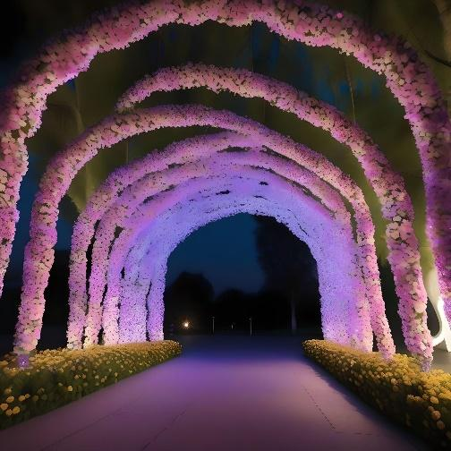

*1Examples of the interactive installation implementation*

**Interaction Flow**

Below are the expected interaction flow of visitors at GLOW:

1. Visitors approach the hedge
2. Upon stepping closer, the lights on the floor illuminate, responding to their presence through sensors/pressure plates.
3. Visitors can engage further by touching the touch-sensitive sensors on the poles/walls of the hedge.
4. Upon touch, a subtle glow emanates from between the flowers, enhancing the visual appeal of the installation.
5. The brightness of the lights gradually diminished the further away from the active sensor.

Inspirations

* GROW by Daan Roosegaarde
* FLOW by Squidsoup